Cells – How do they carry out the activities of life?

A cell is the smallest unit that is alive. In other words, a cell is the smallest thing that can carry out the activities of life. For example, cells can respond to their environment, acquire and use energy, grow, reproduce, and maintain homeostasis.

1. Watch the video of an animal cell chasing and then eating bacteria (https://www.youtube.com/watch?v=Z_mXDvZQ6dU). What are two activities of life that are demonstrated by the animal cell?

To carry out the activities of life, all cells have the following parts:
- DNA, the genetic material, which gives the instructions for making proteins
- ribosomes, the molecular machines that make proteins
- a cell membrane that surrounds the cell and regulates what gets into and out of the cell
- cytoplasm, which includes:
  - the cytosol (water with dissolved proteins and other substances)
  - the structures in the cytosol, including ribosomes and the cytoskeleton, which is a network of protein fibers that contribute to the structure and movement of the cell.
(For example, molecular changes in the proteins of the cytoskeleton caused the movement of the animal cell as it chased the bacterium.)

2a. How do proteins contribute to the activities of life listed in the first paragraph?

2b. Describe how the cell parts listed in this table contribute to the activities of life.

Cell Parts | How These Cell Parts Contribute to the Activities of Life
DNA and ribosomes
Cell membrane

3. In this activity, you will learn how different types of cells carry out the activities of life. To begin, describe any differences between animal cells and bacterial cells that you already know about.

Animal cells and bacterial cells are examples of two fundamentally different types of cells, which are described in the table and figure below.

In a eukaryotic cell, the DNA is surrounded by a nuclear membrane. | In a prokaryotic cell, the DNA is not surrounded by a membrane.
An animal or plant has multiple eukaryotic cells. There are other types of multicellular eukaryotic organisms. Some organisms consist of a single eukaryotic cell. | A prokaryote is an organism that consists of a single prokaryotic cell. Bacteria are one type of prokaryotes.

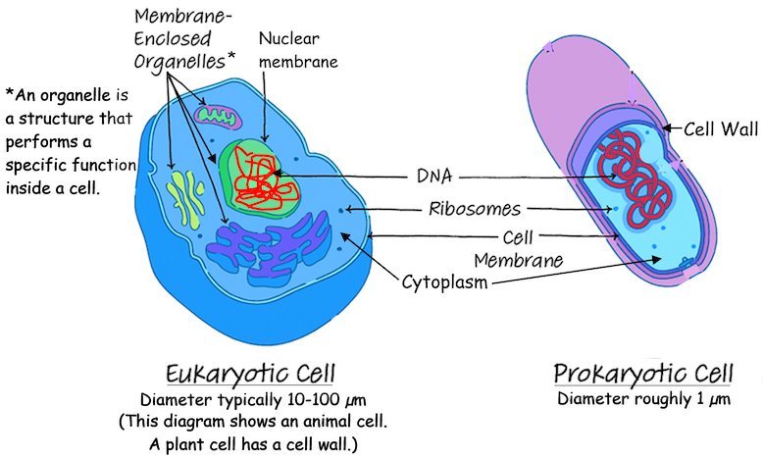

4a. Based on the information in the figure, the diameter of a eukaryotic cell is ____ - ______ times bigger than the diameter of a prokaryotic cell.

4b. Draw the outline of a prokaryotic cell that is about 1/10 as wide as the diagram of the eukaryotic cell. This will give a better picture of how much smaller a prokaryotic cell is.

4c. To make a rough comparison of the volumes of these two types of cells, assume that cells are spherical and the diameter of a eukaryotic cell is 10 times the diameter of a prokaryotic cell. How much bigger would the volume of the eukaryotic cell be, compared to the volume of the prokaryotic cell? 10 times bigger ___ 100 times bigger ___ 1000 times bigger ___

4d. Eukaryotic cells are bigger than prokaryotic cells, but they are still tiny. View the animation at https://learn.genetics.utah.edu/content/cells/scale/. Which is the biggest?
a grain of salt ___ a red blood cell ___ a skin cell ___

5. Eukaryotic and prokaryotic cells are very different in size and internal structure, but they both have a cell membrane, DNA and ribosomes. Explain why cells need these parts to be alive.

Some types of prokaryotes can cause diseases such as tuberculosis. These bacteria take nutrition from our bodies, without helping us with any activities of life. However, we would not be better off if we could somehow eliminate all prokaryotes.

Some prokaryotes have chemical abilities that eukaryotic cells lack. All organisms need nitrogen atoms in the amino acids in their proteins. N₂ is abundant in air, but plant and animal cells cannot use N₂. Some prokaryotes can use N₂ to make NH₄⁺, which they use to make amino acids. Fortunately, these prokaryotes produce excess NH₄⁺, which plants can use to make amino acids. Animals get nitrogen atoms by consuming proteins in the food they eat.
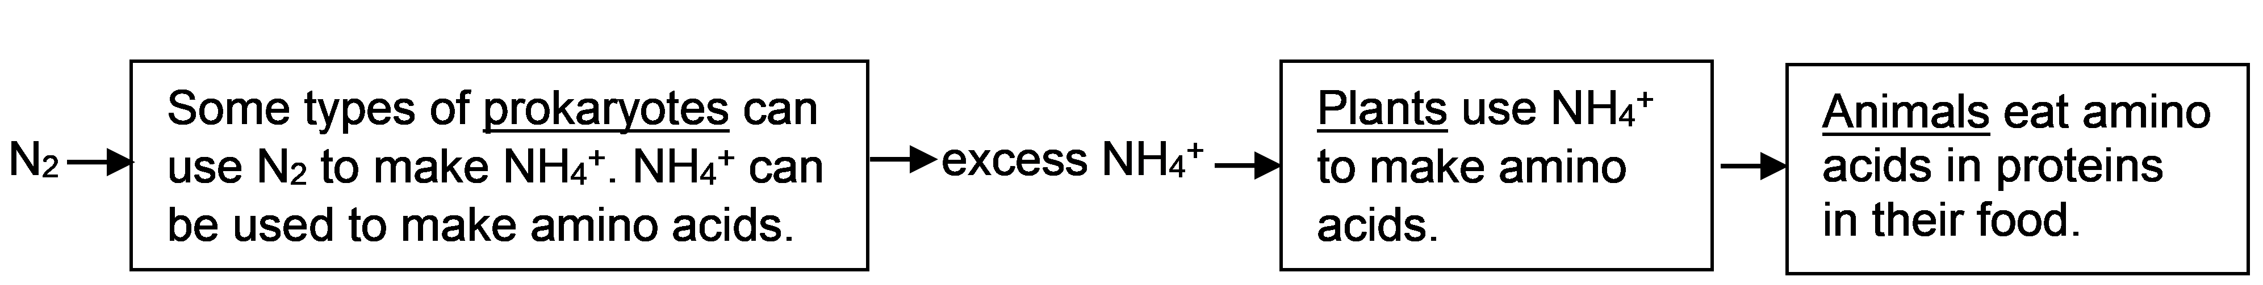

Another benefit comes from the roughly 40 trillion prokaryotes that live in your gut and on your skin. These prokaryotes benefit you by making some vitamins and improving your digestion and resistance to infection. These prokaryotes benefit from the food provided by your body.

6. Describe two examples that illustrate how some types of prokaryotes benefit humans.

To review and learn more, watch the video, “Prokaryotic vs. Eukaryotic Cells” (https://www.youtube.com/watch?v=Pxujitlv8wc). This video mentions two major types of prokaryotes – bacteria and archaea, which are very different at a molecular level.

When your body has been infected by disease-causing bacteria or fungi, you may need a medicine that can interfere with a molecular process that the infecting cells need, but human cells do not need. For example, antibiotics exploit the molecular differences between bacterial cells and human cells to interfere with molecular processes needed by bacterial cells, without killing human cells.

7a. The video states that you need different medications to treat fungal vs. bacterial infections. What can you deduce about differences between fungal cells, bacterial cells, and human cells? Explain your reasoning.

7b. Archaea in your body may contribute to some diseases, such as gum disease. Propose a likely explanation for why many medicines that inhibit the growth of bacteria do not work against archaea.

An organelle is a structure that performs a specialized function inside a cell. For example, ribosomes make proteins. Eukaryotic cells also have several types of organelles that are surrounded by membranes.
- The nucleus contains the DNA which gives the instructions for making proteins.
- In a eukaryotic cell, some of the ribosomes are attached to the membranes of the rough endoplasmic reticulum. The proteins produced by these ribosomes are processed in the rough endoplasmic reticulum and the Golgi apparatus. Then, vesicles carry these proteins to the cell membrane, where the proteins are secreted from the cell (e.g., protein hormones) or become part of the cell membrane (e.g., protein pores).
- Mitochondria make ATP, which provides the energy needed for many cellular processes.
- In animal cells, lysosomes contain enzymes that digest worn out cellular materials. These enzymes also digest any bacteria eaten by a cell.

8a. This diagram of an animal cell shows several organelles that work together to make and process proteins that are secreted from the cell. Next to the name of each of these organelles, briefly describe its function.  8b. Circle the name of the organelle that makes the ATP that provides the energy for protein | 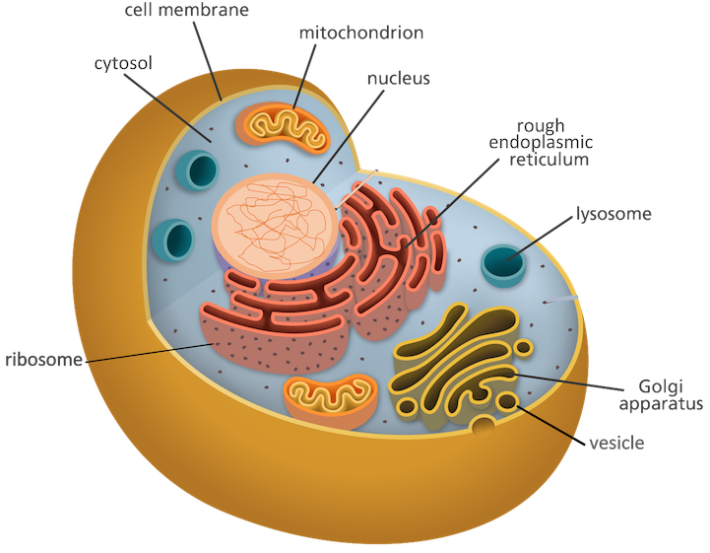
production and secretion.
This figure shows how proteins are moved from the rough endoplasmic reticulum to the Golgi apparatus and from the Golgi apparatus to the cell membrane. A vesicle containing proteins is carried by a motor protein that walks along a microtubule, which is part of the cytoskeleton. |  | 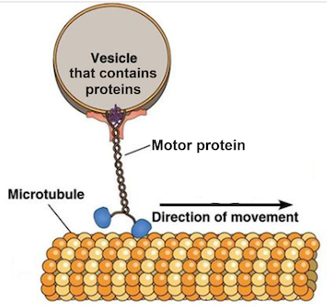
9. This figure shows that vesicles carry proteins from the rough endoplasmic reticulum (rough ER) to the Golgi apparatus and from the Golgi apparatus to the cell membrane. How does the cell move these vesicles? | 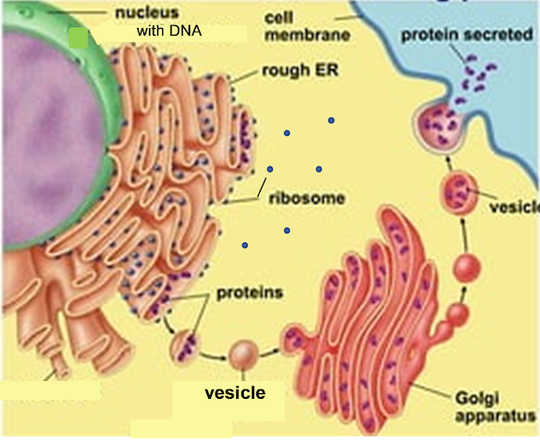

10. The different parts of a eukaryotic cell work together to accomplish the cell’s functions. Some eukaryotic cells can be thought of as a factory that makes proteins and ships them out. Which parts of the cell accomplish each of the listed functions?

Factory Function | What part or parts of the cell  accomplish this function?
Management – sends out instructions
(DNA –> RNA)

Workbench – uses instructions (RNA) to make products (proteins)

Processing – prepares products (proteins)
to leave factory/cell

Transport – moves products (proteins)
in factory/cell

Security Fence with Gates – controls what
comes into or leaves the factory/cell

Powerhouse – provides energy in a form
the factory/cell can use (ATP)

Cleanup crew – disposes of worn out
products and equipment

To see an animation that illustrates some of the constant activity inside a cell, watch from approximately 3 minutes and 45 seconds to 6 minutes and 40 seconds in the video, “The Inner Life of the Cell” (https://www.youtube.com/watch?v=6wGAVxe7cik). This recommended segment shows how (1) vesicles are transported by motor proteins along the microtubules of the cytoskeleton and (2) proteins are synthesized by ribosomes and processed by the rough endoplasmic reticulum and Golgi apparatus. Don’t worry if you don’t understand everything the narrator says.
One advantage of being multicellular is that different cells can specialize for different activities of life. For example, human sperm cells are specialized for reproduction. They have a specialized structure that helps them reach and fertilize an egg (which is a crucial step in sexual
reproduction).  11a. Explain how the flagellum of a sperm cell contributes to sperm function. (Hint: View swimming sperm at https://sites.tufts.edu/guastolab/movies/.) | 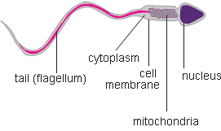

11b. Why is it an advantage for a sperm cell to have very little cytoplasm and lots of mitochondria?

11c. In biology, function is related to structure. Structure includes shape, which parts are in a cell, and how the parts are organized. Give an example of the relationship between structure and function in sperm.

The animal cell in the first video was a phagocyte, a type of white blood cell that defends our bodies against infection by eating bacteria. Phagocytes squeeze between the cells of the capillary wall to move from the blood to an infected injury. Then, phagocytes engulf the bacteria. The chemicals and enzymes in the phagocytes’ lysosomes kill and digest the bacteria.
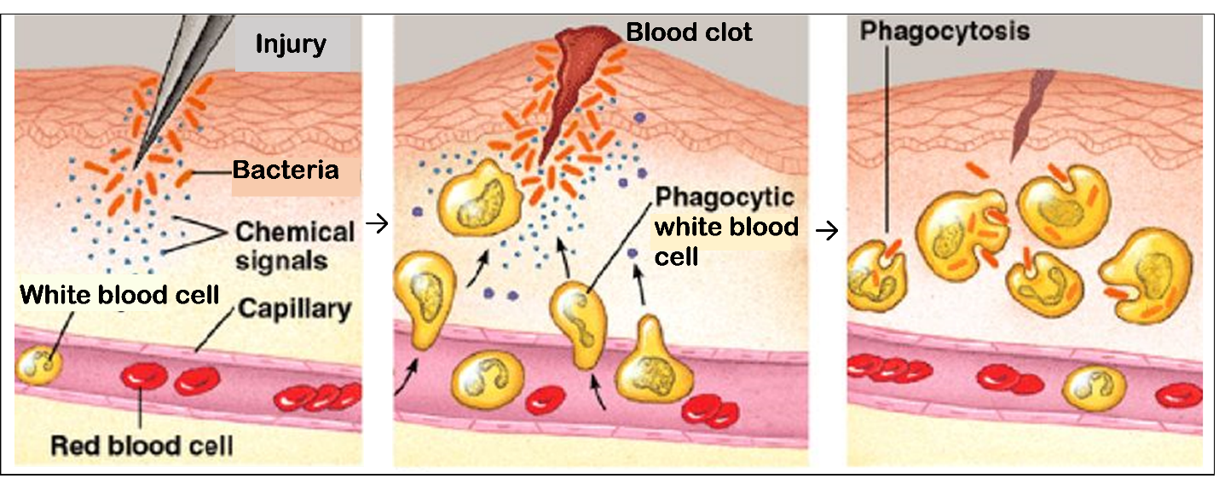
12a. Why do phagocytes need to be able to change shape in order to accomplish their function?

12b. Each phagocyte has many more lysosomes than a typical animal cell. Explain how the many lysosomes help a phagocyte to accomplish its function.

Many parts of plant cells are also found in animal cells, but plant cells have several additional cell parts. Specifically, plant cells have:
- chloroplasts, which use light energy, CO₂ and H₂O to make sugars,
- a cell wall, which provides structural support,
- a large central vacuole, which stores cell nutrients and waste products.
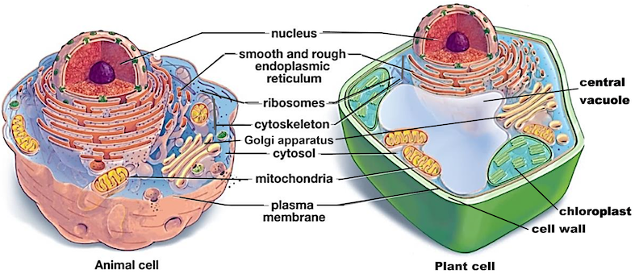

13. In the diagram of the plant cell, draw an arrow from the organelle that makes sugars to the organelle that uses sugars in a process that makes ATP.

14. Explain why each of the structures listed in the table is useful for plant cells, but not needed or even a disadvantage for animal cells.

 | Why This Part  is Useful in Plant Cells | Why This Part is Not Needed or is  Even a Disadvantage for Animal Cells
Chloroplasts
Cell wall

15. Complete this Venn diagram to summarize the similarities and differences between eukaryotic and prokaryotic cells. In the appropriate areas, list parts that are observed only in eukaryotic cells or in both eukaryotic and prokaryotic cells. Put an asterisk (*) next to parts that are found in plant cells, but not in animal cells.
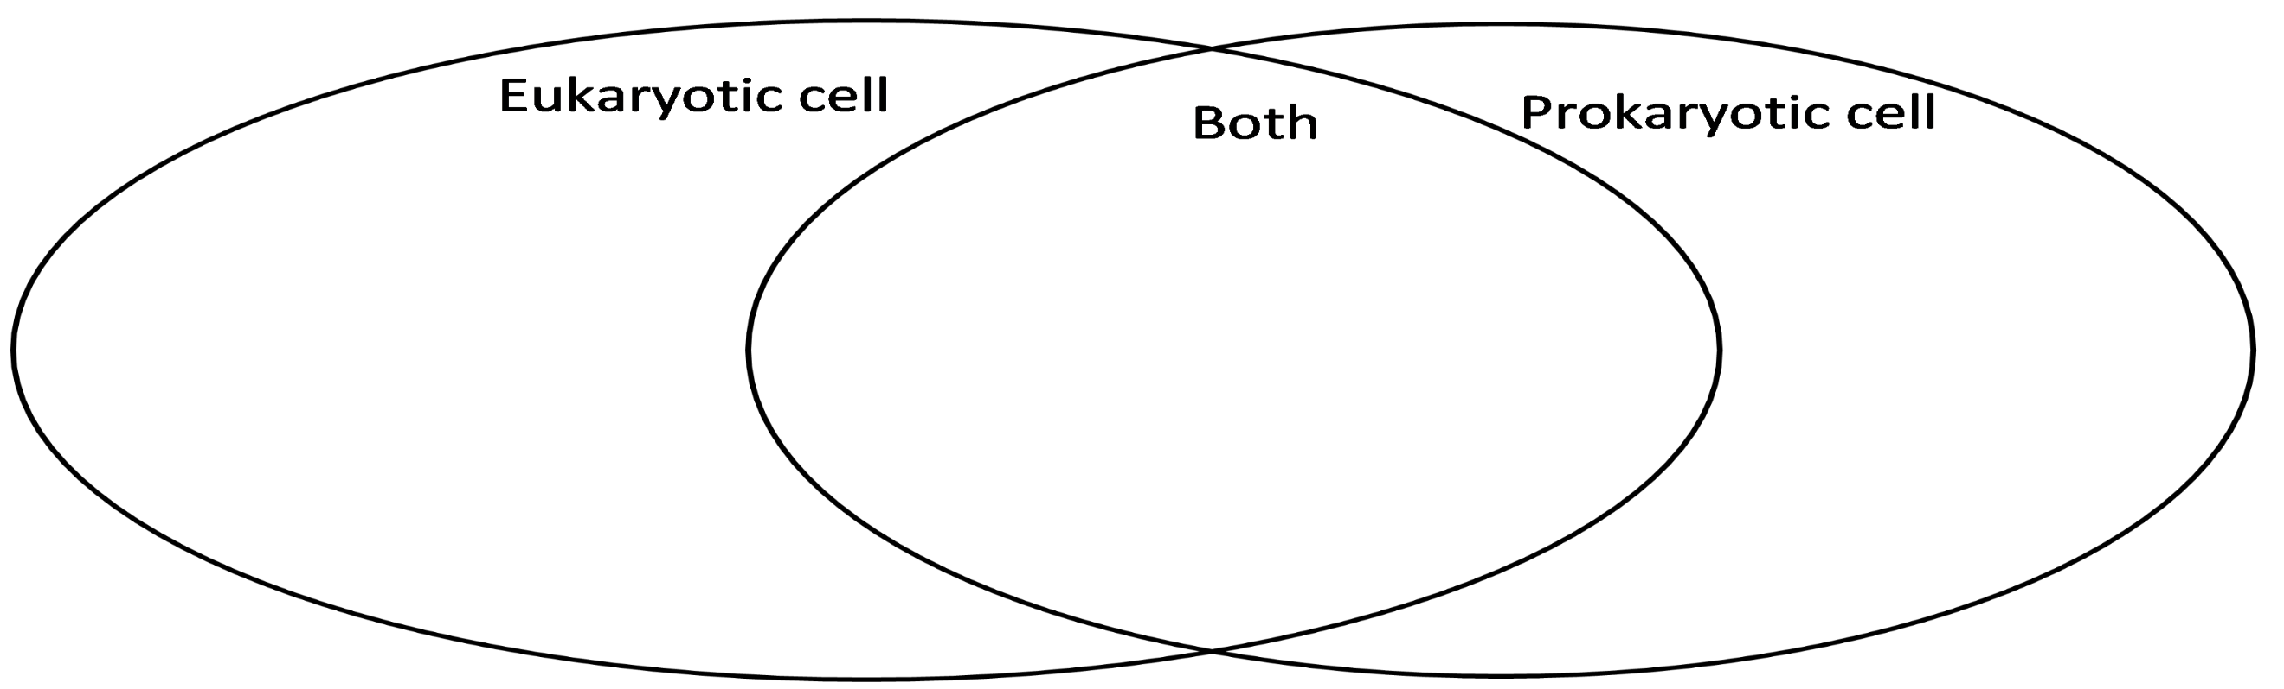

By Dr. Ingrid Waldron, Department of Biology, University of Pennsylvania, © 2024. This Student Handout and Teacher Notes with instructional suggestions and background biology are available at https://serendipstudio.org/exchange/bioactivities/Cells.

